

LAO PEOPLE’S DEMOCRATIC REPUBLIC
Peace Independence Democracy Unity Prosperity
∗∗∗∗∗∗∗∗ÜÜÜÜÜ∗∗∗∗∗∗∗∗

Secretariat of the Country Coordinating Mechanism
Global Fund to Fight AIDS, Tuberculosis and Malaria
No.............../CCM.Sec.GFATM

​Report of Oversight Field Visit

Borlikhamxay Province date 28th-31st March 2016

Main Purpose:

To oversight the implementation of the projects supported by the Global Fund to Fight AIDS, Tuberculosis and Malaria (GFATM) at provincial, district and health center level accordingly to the oversight schedules, and focused on five key issues: finance, procurement, implementation, results (output/outcome), and reporting system in order to supervise the implementation of the projects, activities executed according to plan and oversee the achievement of the targets.

​ Target sites:
- Date: 28th March 2016: - Provincial Health Department of Borlikhamxay Province

- Sector of HIV/AID, Tuberculosis and Malaria

- Date: 29th March 2016:: - Health Office of Parkkading District

- Hospital of Parkkading District

- Unit of HIV/AID, Tuberculosis and Malaria

- Namthone Health Center

- Parkkading Health Center

- Date: 30th March 2016: - Health Office of Thaphabath District
- ​Hospital of Thaphabath District ​​
- Unit of HIV/AID, Tuberculosis and Malaria
- Houy Leuk Health Center
- Parkthouy Health Center

Summary of Results:

The teamwork has discussed with the Provincial Health Department, District Health Office and Health Centers about the status of the implementation of the GFATM, and additionally analyzed the progress of supported projects, strengths to learn, weakness to improve and key issues to resolve.

1. Finance
Findings | ​Provincial Level | ​District Level | Health Center Level
Key Progress | HIV/AIDS  - Received funds from the Global Fund for the AIDS and sexually transmitted infection (STI) activities for a 6 months period. At the end of 2015: the total of Q3 was 37,891,522 Kip and Q4 specifically 33,451,290 Kip  - Monitoring at a district level, one time per year including 5 districts: Pakxan, Borlikhan, Thaphabath, Pakkading and Khamkeurt. Total of 3,718,000 kip  - Quarterly meeting with colleagues at the provincial level. 6,278,000 kip.  - Trained volunteers to work with Outreach Workers and Man Sex Man (OW and MSM). 2,957,000 kip  - Monitoring the activities of OW and MSM. 5,817,000 kip  - Training 17 MSM.  9,922,000 kip  - Incentive payments to the 17 MSM in 5 districts such as: Pakxan, Borlikhan, Thaphabath, Pakkading and Khamkeurt. 32,966,000 Kip  - Monitoring the field activity MSM.  9,211,000 kip  - Visited the infected patients within 11 families in 3 districts: Pakxan, Pakkading and Thaphabath. 4,800,000 kip  - Gathering the infected group.  600,000 kip  - Monitoring patients who lacked of drug within 3 districts: Pakxan, Pakkading and Thaphabath. 2,560,000 kip  - In year 2014-2015 Received by the government the total budget of 24,410,000 Kip  - Advertised basic information on AIDS/STI, use condoms, placed blood testing within 2 districts (Pakkading and Khamkeut) and including 4 villages. Furthermore, promoted information on how to find and access the target groups, and advised on how to live with the patients without discrimination. Total number of participants: 253 including 146 women and using the amount of 4,410,000 kip  - Training in Reporting Form for officials at the province level including provincial hospitals, National Defense, and other 7 districts. A total of 26 participants including 18 women. Total cost of 9,000,000 kip.  - Annual Summary Meeting of AIDS/STI in Viengthong District with a total of 50 participants. Total cost of 11,000,000 Kip.  Representative of AIDS Unit of Bolikhamxay Province reported:  - Received the amount of $3,718 or 30,068,000 kip from the Global Fund for Q1 to Q4, January to December 2016. The costs are for:  - Office management, water, electricity, telephone, internet and other supplies for a total cost of 15,524,000 kip  - Supporting 1 financial & accountant staff for the amount of 8,244,000 kip  - Supporting 1 accountant staff of warehouse for the amount of 6,300,000 kip  - Remark: LaoPha donor has not supported the finance  Malaria:  - No budget during the period of 2014-2015  - Received 50,000,000 kip in 2016  - Carried out the financial regulation of Global Fund(GF)  Tuberculosis:  - Received the amount of 61,686,000 kip for Q3 and 53,549,000 kip for Q4 in the year 2015 | - Pakkading District:  HIV/AIDS  - No budget for activity  - ​Received fund from another source  Malaria: ​  - Budget for Malaria activities: 3.366.000 kip  - District used the amount of 2,124,000 kip for monitoring health centers and villages  - Health center used 1,242,000 Kip for collecting information at the village level.  - Budget for dengue fever and parasites: 4,645,000 kip  - Meeting about the dengue fever and parasites organized by the District hospital committee and the health center: 3,205,000 kip  - Surveys water worm in 6 target villages for the amount of 1,440,000 kip  Tuberculosis:  - Received the amount of 6,039,000 kip for the activities; already used 5,349,000 kip and remained 690,000 kip  - Fee for sending the sample from health center to district (amount not available).  - Thaphabath District:  - HIV/AIDS: No budget for the activities, however supplied (HIV Rapid Test) to find HIV infection.  Malaria:  - Received the amount of 42,000,000 kip from the Global Fund in the year period of 2014-2015  - Budget provided by Government support  Tuberculosis:​  - Received funds from the province level and from the Government to:  -Monitor the villages  -For office management  -To monitoring the activities | Tuberculosis:  - Budget available only for sending sample  - Program does not have proper funds, therefore need to joint other projects to execute the activities
Key  Issues | Tuberculosis:  - Budget to conduct the activity is limited  Malaria:  - No budget for making the blood test analyzes  - Monitoring the financial support from the central to the province, have been executed only once a year. When normally shall be done three times per year.  - DSA for staffs is quite low  Tuberculosis:  - The fund for sending sample is delayed and too short to make a completely analyze  - The fund has not been transferred to the province on time | HIV/AIDS  - No budget for monitoring  - Lack of staff with training on HIV, low quality and delayed work  - Lack of funding in AIDS work  - Lack of staff, there’s no personal specialize in the technical performance of the project causing delays in the reports  - Lack of fund for AIDS Activities  Malaria  - The approval of the budget was delayed.  - No budget for monitoring the activities, therefore need to joint other projects to execute the activities  Tuberculosis  - Some activities are delayed  - The budget was not received as specified | HIV/AIDS  - No budget for conducting the activities  - No budget for monitoring  Malaria  - Village volunteer is not active  - The fund was not received on time  - No budget for monitoring the activities  Tuberculosis  - No budget for implementing the IEC  - No advertising brochures  - No budget for monitoring the project therefore need to joint other projects with the Government to execute the activities
Recom-mendation | HIV/AIDS  - The coordinator should improve monitoring activities  - The budget management should be provided to the district and health center  Malaria  - Central should transfer the funds timely as quarterly planned  - Province should concluded timely as quarterly planned  - Central should improve the rate of allowances for staff appropriately  - District should conclude activities timely, specifically, within 7 to 10 days  - Health center and village volunteer should conclude their work timely  - Central should allocate and provide more funds  Tuberculosis  - Province level should ensure to report timely as scheduled  - The budget should be provided to the district staff to deliver samples timely and to increase the case detection | HIV/AIDS  The program should specifically train someone from the staff in financial matters. The Government has to contribute to this training.  Tuberculosis  - The province should spend more time for monitoring and arrange more funds for the district | HIV/AIDS  No identify  Tuberculosis  - The district should arrange more funds for the health center and provide more time for monitoring

 | 2. Procurement
 | Findings | ​Provincial Level |  | ​District Level | Health Center  Level
 | Key  Progress | HIV/AIDS  - No procurement  - Medical equipment (Rapid Test) remains 200 units that used for 8 VCT conduction  Malaria  - Submitted procurement plan for 44,990 mosquito nets  - Can perform according to the regulation of the Global Fund  - Allowance to purchase only office supplies  Tuberculosis  - The purchases were made on time as proposed  - Received medical equipment and drugs on time |  | - Pakkading District:  HIV/AIDS  - No procurement  - Received equipments from Provincial HIV/AIDS Sector:  - Determine 160 tests  - Unigold 20 tests.  - Condom 39 Boxes.  Malaria  - Received 1,300 mosquito nets from province  - Medical equipments were provided by the province  - Drugs are sufficient  Tuberculosis  - Province is responsible for procurement | HIV/AIDS  - No procurement  Malaria  - No procurement  - Medical equipments and drugs were provided by the province  Tuberculosis  - Province can only provide treatment to health centers with Tuberculosis patients
 | Key  Issues | HIV/AIDS  - Condoms are not enough in the VCT conduction.  - No procurement, but only purchase the office supplies  - Lack of office supplies: audio, LCD Projector, etc.  Malaria  - Procurement of mosquito nets was not followed according to plan. The Company has not delivered 44.990 mosquito nets, but 44,250 mosquito nets  Tuberculosis  - The medical equipment delivery was delayed and presented difficulties to deliver to some rural districts |  | - Pakkading:  HIV/AIDS  - No procurement  - Not enough essential equipment and very old office supplies  Malaria  - No procurement  - No identify  Tuberculosis  - Lack of office and electronic supplies, such as: computer, printer and document shelf | HIV/AIDS  - No identify  Malaria  - No procurement  - No identify  Tuberculosis  - No procurement
 | Recom  mendation | HIV/AIDS  - Not enough condoms. Central should allocate the condoms sufficiently  Malaria  - Procurement should be done according to the regulation  - The central should follow up the completely delivery of the remained mosquito nets  Tuberculosis  - The central should monitor the findings by coordinating with the provincial level |  | HIV/AIDS  - No identify  Malaria  - No identify  Tuberculosis  - No identify | HIV/AIDS  - No identify  Malaria  - No identify  Tuberculosis  - No identify
3. Implementing
Issues |  | ​Provincial Level | ​District Level |  | Health Center  Level
Key  Progress |  | HIV/AIDS  - Monitoring in district level, one time per year including 6 districts: Pakxan, Borlikhan, Thaphabath, Pakkading, Khamkeut and Viengthong  - Quarterly meeting with colleagues in the provinces  - Trained in OW.MSM for the volunteers  - Monitoring activities of OW.MSM  - Trained for 17 MSM  - Conducted IEC and incentive payments to the 17 MSM in 6 districts: Pakxan, Borlikhan, Thaphabath, Pakkading, Khamkeut and Viengthong  - Monitoring the MSM activity  - Visited 11 families of infected patients in 3 districts: Pakxan, Pakkading and Thaphabath  - Gathering infected group of patients  - Visited 3 districts for the patients lacking drugs: Pakxan, Pakkading and Thaphabath  - Under the guidance of the leaders, the projects were successfully implemented.  - Each team/partner kindly facilitated the cooperation in implementation as accorded.  - Received the implementation budget (supported by government and international organization)  - The responsible staff for the HIV/STI in each district practiced their role as assigned on the upper level  - Cooperation from the local authorities  Malaria  - Monitoring guidance on the reporting system  - All actions are directed by the leader and concerned organizations  - Malaria cases are generally low except in some districts and remote areas  - The mosquito nets were delivered to each district  - The distribution of mosquito nets for infected patients  - Medical treatments are enough  Tuberculosis  - Carried out the implementation of the project activities  - Able to treat patients with tuberculosis  - Gen-Xpert to support the diagnosis of tuberculosis case  - Overall, the implementation of activities was conducted as the planned  - The reports were usually submitted on time  - Most of the activities achieved their targets  - Ensured that warehouse were not lacking medicine | HIV/AIDS  - Under the guidance of the leaders, the projects were successfully implemented.  - Good cooperation from the local authorities  - The responsible staff for HIV/STI of each district practiced their role assigned by the upper level.  - Conducted survey of guesthouse, hotels, restaurants, bars and karaoke, women workers and other services over Pakkading District.  - Conducted IEC to create awareness in basic knowledge about AIDS and STIs in some villages.  - Pregnant women who have use our service were also tested for seeking HIV  Malaria  - Activities to monitor malaria in district level and health centers in target villages – 4 times  - Delivered the new dyed-liquid mosquito nets to health center and villages - 1 time.  - Activities to control dengue in district level and health center conducted by the IEC in the target village -1 time.  - Meeting with district committee and village committee to fight against dengue fever - 1 time.  - Strengthen the Surveillance system for malaria in Pakkading District  - Data collection from the target villages was completely and timely.  - Acknowledged of malaria cases  - Monitor illness, deaths from malaria cases in each district.  - Collect, compile data and monthly report to the provincial malaria station.  - Rate of malaria cases are decreased in average of 0.6 /1,000  - No cases of malaria deaths  - 40 Cases of dengue fever.  - Monitoring surveillance of dengue fever and survey for water worm over the district.  - Surveyed for 6 target villages and 217 families  - The percentage of mosquito water larvae (HI) = 6,27%  - The percentage of containers with mosquito water larvae (CI) = 2,0%  - Density of the mosquito water larvae (BI) = 6,96  Tuberculosis  - Incompletely Implementation of the activities  - Detection of tuberculosis cases in villages  - Visited tuberculosis patients in villages  - Conducted monitoring in health centers  - Every day, conducted testing of suspected patients |  | Malaria  - Activities to monitor malaria. Collected data in health centers in target villages - 4 times.  - Activities to monitor dengue fever. The health center conducted an IEC within district level in target village -1 time.  - Target patients are using the services regularly  - The majority of health centers have a good performance  - Good integration and cooperation within the district level for implementing the activities  Tuberculosis  - Identify tuberculosis patients  - Advertising in villages for IEC through village volunteers
Key  Issues |  | HIV/AIDS  - ​Implementation of the SW made by PEDA in three districts of the province was not completed.  - Conference quarterly Monitoring: the secretariat of HIV/AIDS did not attend, only attended the SW training (once a year).  - Lack of fund for conducting the IEC  - Unable to perform the task and completely suppress anti HIV/AIDS-STI because of the lack of budget.  - Unable to conduct the IEC  - Prevention activities are limited causing the control of HIV-STIs is not carried out.  - Voluntary Blood testing not well execute due to the lack of coordination between the responsible officer for AIDS, Mother and Children and Tuberculosis.  - Responsible staffs for AIDS/STIs in provincial and district level have not experience and are frequently replaced without any training.  Malaria  - Vehicles for conducting the monitoring are insufficient.  - The coordination between the central and province is not synchronized and the feedback is always delayed.  - The activities of case performance were delayed in all districts due to the insufficiency of equipment and vehicles.  - Monitoring of the patients’ families is difficult; many of them are not living anymore in the province and have moved to other areas.  Tuberculosis  - Low detection of suspected cases, decreased of delivered samples by health workers, DTM of some districts have several duties and they wait for the patients to come to the hospital  - Practicing of DOT in district and health center is not well perform (problem of drug resistance)  - When the province level conducted monitoring in the district level, some districts were not attentively cooperative and failed to follow the suggestion or work guideline  - Monitoring for the months of February, March, May, June and August was incomplete and delayed.  - When a district conducted monitoring in health centers, their recommendation were not fully followed: not properly record of used medicine treatment, registration book, well recovery, ended treatment, dead and patients’ cards not been returned to the TB.  - When monitoring in villages, detection of tuberculosis cases is low. | HIV/AIDS  - The responsible staff for AIDS/STIs in district level lacks of experience mainly because of frequently replacement without training.  - Responsible staff for AIDS/STIs in each health center lacks of academic experience and have never been trained in AIDS/STIs.  - Some health centers have not reported timely.  - Lack of equipment used in TB workshops: audio, LCD Projector, etc.  - Lack of budget for conducting IEC  Malaria  - One person is responsible for several duties and frequently replace and move to work in another place  - Equipment and vehicle are limited and in many places there is no  - Population in some areas does not have good knowledge of the disease  - Most patients are not local people coming from the province, they have moved to other areas, therefore finding the case is difficult and complex.  Tuberculosis  - When there is only one person responsible for the Tuberculosis sector, and this person is absent, there is no one to report and/or to continue the patients’ treatment  - When a tuberculosis patient come to the hospital and case is suspected is very difficult to treat her/him because the tuberculosis team is located at the health office of district - not at the hospital-, creating difficulties to communicate, analyze and continue patient’s treatment.  - The budget is delayed  - The vehicle is broken and could not be used. |  | HIV/AIDS  - Officials of some health centers are frequently replaced and have not good understanding about their work causing delays in collecting the data and reporting.  - Village volunteer of some villages rarely stay at home, provoking the collection of data to be incomplete and out of date.  - Reduce budget can not implement many activity  - Condom have not been provided by the project  - Lack of academic knowledge from the responsible AIDS/STIs staff in each health center.  Malaria  - Several new staffs do not have a good understanding about malaria  - Medical equipment is insufficient  - Time schedule is not detailed  - Staffs are not being enough cooperative  Tuberculosis  - Lack of IEC conduction  - Conduction of DOT with patients is difficult, village volunteers do not receive any incentive or any contribution from the patients  - Lack of budget to deliver the samples
Recom  mendation |  | HIV/AIDS  - Should provide continuously training on project management for the provincial and district team  - Should provide budget to cover and guarantee quality in preventing HIV infection.  Malaria  - Should provide new equipment such as computers and printers. Office supplies are very old and cannot be use  - New vehicles should be provided in order to work more quickly and efficiently  - Central should spend more time to monitor and advertise over the infected areas to create more knowledge and understanding  - ​When the oversight committee team conduct a field visit, the malaria unit should prepare a detailed report to distribute to all participants during the meeting  Tuberculosis  - Central and provincial level should provide the training course for the new staff members  - Advertise over the community areas | HIV/AIDS  - Same as provincial level  Malaria  - Should provide more equipment and vehicles  - Should reconsider task and responsibilities of each staff member and improve the working method  - The responsible person for malaria at the provincial level conducted monitoring and advertised in target areas to create more understanding about malaria infections  Tuberculosis  - Tuberculosis sector should consist of at least 2 responsible staffs  - A team for tuberculosis should be standing at the hospital  - Provincial level should spend more time for monitoring  - Advertise over the community areas |  | HIV/AIDS  - Same as provincial level  Malaria  - Should provide more equipment and vehicles  - Should consider appropriately responsibility of each staff and improve working method  - District level should spend more time for monitoring health centers and villages

4. Reporting
Issues | ​Provincial Level | ​District Level | Health Center  Level
Key  Progress | HIV/AIDS  - Quarterly reporting  Malaria  - Provincial level reported regularly to the central  Tuberculosis  - Quarterly report according to the plan of each level: health center–district–province–central  - Reporting statistics every 3 months  - Health centers usually report to district on the 3rd of every month.  - District usually reports to the province on the 5th of every month.  - Province usually reports to the TBC on the 10th of the coming quarter.  - For financial reports every month, reports should follow the required form provided by TBC. | HIV/AIDS  - Mostly reports regularly  - 2 villages: Nam Deua and Houy Phet participated in training for reporting form of AIDS.  - Reporting of figures VCT each quarter  Malaria  - Follow guidance from the provincial level to have a better performance  - Collect the status of the malaria problem  Tuberculosis  - Reporting quarterly to the provincial level, and also every month or any time that difficulty is presented  - Delayed reporting from some health centers | ​ Malaria  - Mostly reports regularly  - Health center usually reports to district on the 3rd of every month and report to the district on the 5th (Monthly)  Tuberculosis  - Regularly reporting, but one of the village volunteer is not active
Key  Issues | HIV/AIDS  - Lack of office equipment such as: computer for preparing the report  - Some districts have presented delay reports and some health centers have missing reports, and calculating figures are not being balance.  - In the case of HIV-TB patients, reporting is not complete due to lack of drugs for ARV  - Most patients have been sent from central  Malaria  - When the oversight committee team conduct a field visit, the malaria unit should prepare a detailed report for distribution to all participants during the meeting  - Report to the provincial level is sometimes delayed because some districts did not submit their report on time.  - Compiling data of district level is difficult and delayed  - Responsible staff performs poorly, there is no financial incentive  - Reporting of blood testing is delayed  - The coordination within district level is not well performed  Tuberculosis  - The number of staffs is limited and there is insufficient budget for regularly monitoring at district level | HIV/AIDS  - Lack of equipment to implementation of activities  - Reporting of some districts is unsatisfactory and incomplete mostly because of the lack of equipment and training from the personal.  - Not all the patients were reported by the district  Malaria  - Delay and incomplete reports from some districts located in remote areas  - The staffs is not systematically trained on the reporting form  Tuberculosis  - No identified | HIV/AIDS  - No activity  - No report  Malaria  - Incomplete reports  - Report forms are incomplete  - Some village volunteers living in remote area and did not reported to health center  Tuberculosis  - Delivery of samples is not good enough
Recom  mendation | HIV/AIDS  - CHAS should conduct more monitoring on reporting from district to province level and province level to CHAS  Malaria  - Reporting should be done through surveillance of disease and reporting along the vertical and horizontal lines  - Offer more training for staffs of district level  Tuberculosis  - NTC should conduct more monitoring and training on the report system according to the work target | HIV/AIDS  - Should provide computers  - Should provide technical training  Malaria  - Province level should conduct more monitoring every quarter  Tuberculosis  - Province level should conduct more monitoring and training on the report system according to the work target | HIV/AIDS  - Should ensure that the reporting forms are sufficiently distributed to the health center and village volunteers  Malaria  - District level should conduct more monitoring in specific villages with reporting problems
5. Summary of findings
5​.1. Key Progress
HIV/AIDS
- Under the guidance of the leaders, the projects were successfully implemented.
- Good cooperation in the implementation among the project team and partners at all levels.
- The project has a budget for the implementation (supported by the government and international organizations)
- The staff that is responsible for the HIV/STI of each district successfully practiced their roles as assigned by the upper level, such as regular monthly report.
- The local authorities cooperated as well.
- For the patients: the access to ARV treatment resulted in the reduction of transmission and death rate.
- Implementation of activities has been achieved.
- Monitoring on implementing activities such as IEC materials have been broadly disseminated.

Malaria
- Guided by both vertically and horizontal levels, the local authorities were cooperative and very accessible.
- The malaria control networks covered all target areas and villages.
- Received grants and materials from the Global Fund, CDCII and government.
- Technical staff and village volunteers from each target villages paid attention on their role and responsibility, acquiring continuous training.
- Surveillance systems for malaria at the provincial and district levels were strengthened.
- Data collection from the target villages was completely and timely.
- Early detection of malaria cases.
Tuberculosis
- Overall, the implementation of the activities was conducted as planned.
- The Tuberculosis case detection rate was increased.
- Good cooperation with other organizations and partners involved in the activities of tuberculosis.
- The reports were usually submitted on time.
- Most of the activities achieved the expected targets.
- Ensured that the medicines will not be out of stock in the warehouse.
5.2. Key Issues
HIV/AIDS
- The staffs that are responsible for AIDS/STIs at the provincial and district levels have not experience as they were recently replaced without any training.
- Activities can be extended to the district level only, have not been extended yet to the health center level.
- The reports from some districts were delayed and incomplete. Some figures from health centers were missing and incorrect.
- Voluntary counseling and testing is not well performed in some place due to insufficient coordination among the project staffs who are responsible for AIDS, Mother and Child Health and Tuberculosis.
- The activities for sex workers implemented by PEDA in 3 districts of the province was not continued. The PCCA secretariat has not been involved in the monitoring and quarterly meeting (the PCCA secretariat only attended the training for SW once a year).
- Lack of equipment for the activities such as: electronic equipment (e.g. audio, LCD projector, etc,...)
- Limited budget for the implementation of the activities.
- Patients were not very cooperative.
Malaria
- Approval of the budget was late.
- Essential equipment was not enough to work (such as old computers)
- Staffs of some health centers have changed frequently their task and responsibilities leading to a poor understanding of their work and delay in the reports and data collection.
- The village volunteer of some villages rarely stayed at home causing the data collection of many months to be missing.

Tuberculosis
- Very low detection of suspected cases (DTMs of some districts have several duties thus health workers samples delivery was low, and reduced to the fact of waiting to the patient to approach to the hospital)
- Practicing of DOT in district and health center is not well performed (creating a problem of drug resistance)
- When the provincial team conducted monitoring at district level, some districts did not paid attention, failing to follow the guidance or work out of the guidance and claiming they have lot of work to do.
- Monthly monitoring for the months of February, March, May, June and August were not completed as defined.
- When the district team conducted monitoring in the health centers their advices were not fully captured, such as: record on the patient’s treatment card, patient’s registration book, recover patients, complete treatment, in the case of dead - cards have not been returned to TB unit at the district level.
- When the team visit the villages, the screening for TB suspected patients was low.

5.3. Solution/Recommendation
HIV/AIDS
- HIV/AIDS and Tuberculosis Units have to collaborate regularly, allocate the budget for district level, health centers especially in remote areas.
- Planning for implementation activity should be done by the provincial level in order to cover the areas of the control of AIDS-STI broadly.
- The central team should conduct more monitoring and supervision.
- Health education should be conducted at the public health areas.
- The specific budget for HIV should be provided .

Malaria
- Staffs should be sufficient or should be selected the one who has suitable capacity for better work.
- Integrate work with other programs to strengthen the district level.
- Provide training on project management for the staffs at all levels.
- Conduct broadly awareness raising to the local people to understand the importance of sleeping in the mosquito nets in order to prevent malaria.
- Increase the budget for monitoring the district, health center and villages
- Improve reporting system by piloting some provinces, districts, health centers and villages to determine the actual lessons learnt.
- Provide some drugs that are lacking at the districts and villages.

Tuberculosis
- Reduce the responsibilities of project staffs to allow more times for them to monitor the health centers and villages (according to suspected cases and estimated number cover by the health centers).
- When provincial and district teams conduct the monitoring, they should be more active and teamwork proactive.
- When district teams conduct the health centers monitoring, they should follow their roles and responsibilities.
- Allocate the staff of the health centers and districts near to the patient’s villages to provide better assistance and daily DOT.

Additional Attention Issues:
- Intensify case finding of TB patients in order to have a better detection rate and achieve national targets.
- Improve the case detection of children patient with tuberculosis
- Improve the case detection of closed patient groups with tuberculosis
- Follow up the treatment to ensure a better effectiveness of treatment, reduce the drug resistance of pathogens and reduced the death of patients
- IEC advertising for the local people to know and understand the symptoms, counseling and prevention, including advise, diagnosis and treatment for people close to TB patients.
- Ensure timely and completely reporting
- Ensure to keep safe copies for each report
- Ensure to support cooperation with organizations and/or other partners involved in the activities to control the tuberculosis disease.

Summarizing the key activities to be carried out:
- Deliver the sample of suspected cases and following up the treatment
- Visit the TB patients in villages
- To retrain the health staffs on how to use the DOT
- Retrain workers for village volunteers on how to use the DOT in community
- Disseminate IEC regarding TB disease via radio and TV
- Monitoring from province to district and from district to health centers
- Monitoring from district to health centers and villages
- Budget for office management

6. Work Plan (2015-2016)
HIV/AIDS
- Provincial Level
- Continue to encourage mobilization for district level to report regularly to gain the STI of all health centers of each district.
- Expand in VCT Xaychamphone District
- Continue to propose the government a budget plan to carry out the HIV/STIs activities in 7 districts for the fiscal year 2015-2016.
- Continue to propose the budget plan for international projects fiscal year 2016-2017
- Promote the access to counseling services, blood voluntary testing, test for STI and the use of condoms.
- Strengthen each level of team performance and increase the participation of communities and infected people.
- Encourage infected people to access counseling service, receive ARV treatment and treat complicated diseases.
- Continue to prevent HIV of MSM in 7 target districts (including 17 PE) access into 272 target people.
- Monitoring volunteers of MSM in 5 target districts (Pakxan, Pakkading, Borlikhan, Thaphabath and Khamkeut)
- Quarter meeting with partners of provincial and district level
- Retraining activity for 17 volunteers of MSM
- Enlighten for Peer in the field of (OW)
- Continue to prevent HIV infection in the population at the aged between 15-49 years to be less than 1%.
- Ensure the rate of HIV infection among the risk vulnerable population to be under 5%

- Pakkading District:
- Continue to report AIDS and STIs regular to Provincial Health.
- Continue to promote voluntary blood testing.
- Conduct the IEC mobile advertising regarding to the basic information of AIDS/STI at the clubs, guesthouses and villages
- Retrain the reporting form for partners in health centers and 2 district hospitals, 2 health centers
- Collect data of hotels, factories, restaurants.
- HIV Committee Meeting at district level.
- Workshop at provincial and district level.

- Thaphabath District:
- Continue to mobilize the health centers to report regularly (STI)
- Continue to treat STI and check the report to submit to the province regularly
- Expand more VCT in 5 health centers over the districts
- Continue to implement the international project budget plan of the fiscal year 2015-2016 (to be completed).
- Continue to implement the government budget plan of the fiscal year 2015-2016 (to be completed).
- Attend the quarterly meeting of provincial level 4 times a year
- Once a year, attend training on revision of STIs treatment, and how to use the reporting form
- Once a year, train on counseling and testing for HIV for health center workers Conduct IEC and enlighten the basic knowledge to prevent HIV and STIs to people in 3 villages and students of 2 Secondary Schools.
- Once a year, visit 3 HIV infected families
- Collect the information of Female Sex Workers and local training on preventing HIV and STIs by local bars once a year
- Once a year, monitor 5 health centers.

Malaria
Pakkading District:
- Workshop at district level.
- Retrain village volunteers on surveillance.
- Monitor at all levels: districts, health centers-villages.
- Implement IEC and make community process including placing water worm.
- Support the operation of dengue control.
- Distribute dyed-mosquito nets to health centers and target villages
- Provide the training on malaria information management to all levels
- Provide training on inventory management to provincial, district and health center levels.

Tuberculosis
- Expansion of the covered services to treat and prevent TB
- Raise public and organizational participation in the control of tuberculosis
- Coordinate with HIV task, vaccination, room testing and better understanding of tuberculosis treatment system and DOT strategy
- Broadly disseminate information for people living in the remote areas
- Determine children in a targeted group to taken INH medicine
- Use appropriate tools to improve the information activities and IEC to find a suspected case of being cough more than 2 weeks in each health center
- Improve referral patients to community hospitals (Sample of phlegm)

7. Proposal
Provincial Level | District Level | Health Center Level
HIV/AIDS  - ​​To provide the training for the staff at provincial and district levels at least 1-2 times per year.  - To provide full set of equipment.  - To provide 1 laptop  - To provide study tour in locally and oversea -1 time per year.  - To quarterly and timely transfer the budget.  - Increase DSA and incentives for the provincial and local staff  - Malaria  - Increase DSA and incentives for the provincial and local staff  - To quarterly and timely transfer the budget.  - To provide full set of equipment.  - Tuberculosis  - To provide the budget for collect sputum samples in remote areas.  - To provide the incentive money for the village volunteers for managing the period of treatment for 6 months (remote areas).  - For units that detected HIV/AIDS cases to be ordered for testing sputum to find TB case  - To provide the budget for activities timely  - To provide lunch cost, gasoline for delivery samples from the health center | ​ HIV/AIDS  - Pakkading District:  - ​​To provide the training for work on HIV/STI at least 1-2 times per year.  - To provide study tour 1 time per year.  - Thaphabath District:  - ​To provide the training for work on HIV/STI at least 1-2 times per year.  - To provide fully set of equipment, audio system, LCD Projector  - To provide 1 laptop  - To provide 1 motorbike  - To provide the incentives to Secretariat staff of district  - To provide study tour in locally and oversea 1 time per year.  Malaria  - To provide help through the vertical authority to encourage the one who is responsible for work to be more intentionally for his/her responsibilities.  - Develop clearing and destroying procession the source of the mosquito regularly in each village.  - In case of illness (fever), don’t be advised to buy the drugs by themselves, but advise for their medical care immediately.  - Tuberculosis  - To provide a printer  - To provide a document cabinet  - Health Center Level  - No Identified | No Identified

8. ​Photo of Monitoring Team
Provincial Health Department
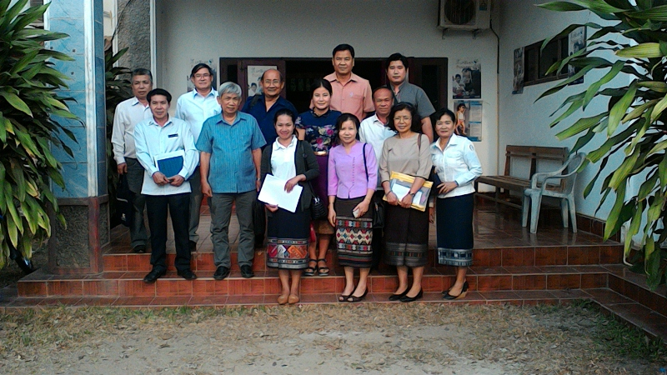

Health Office of Pakkading District

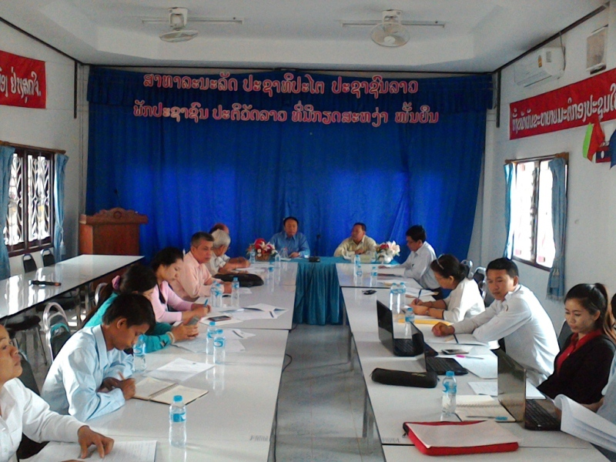

Nam Thone Health Center

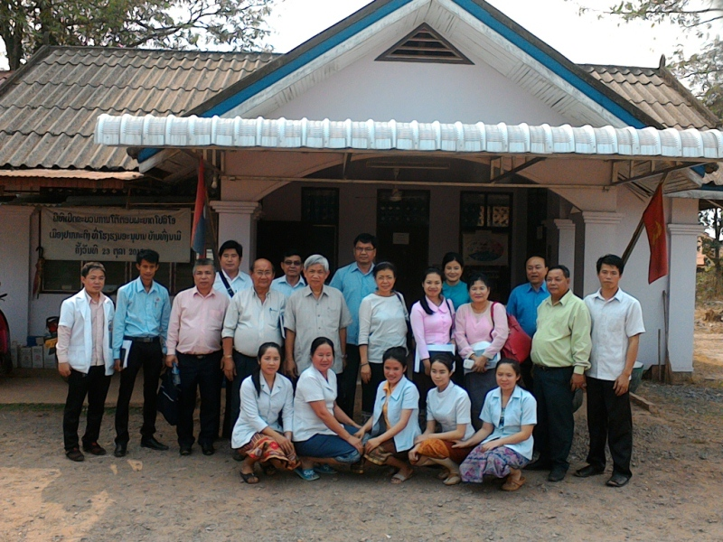

Pakkading Health Center

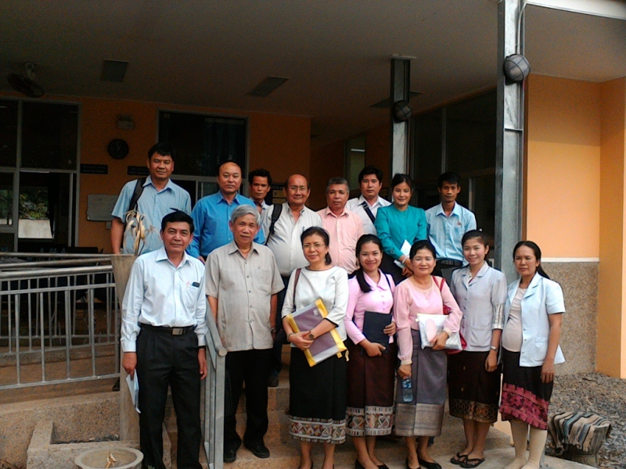

Health Office/Hospital of Thaphabaht District

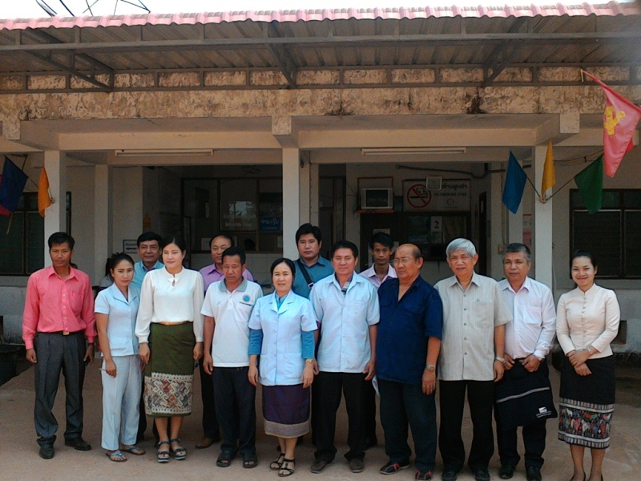

​Houy Leuk Health Center

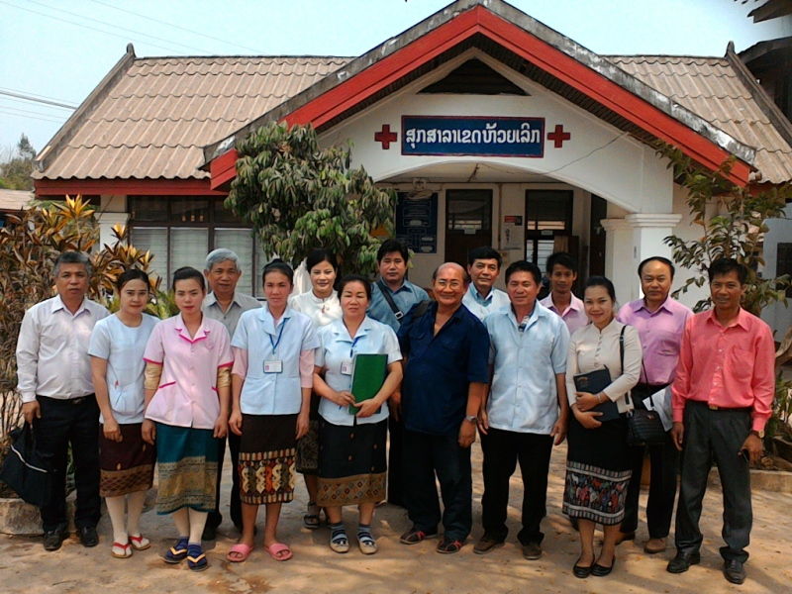

Ban Thouy Health Center

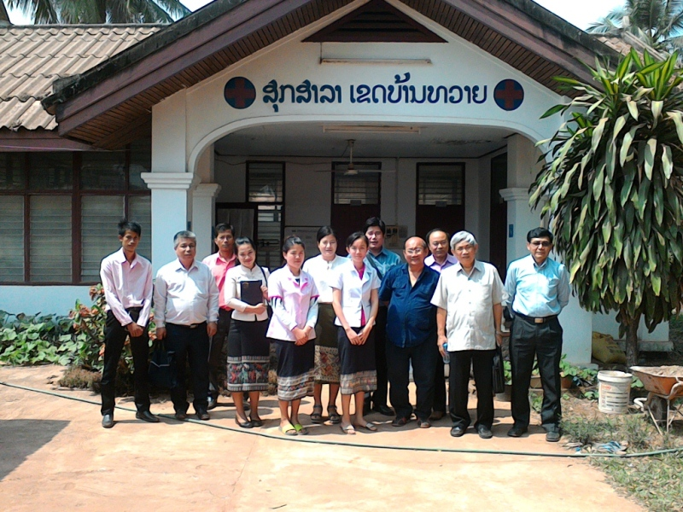

Thanks:
The oversight field visit team of the Country Coordinating Mechanism from the Global Fund to Fight HIV/AIDS, Tuberculosis and Malaria would like to express special thanks to the guidance from the Provincial Health Department of Borlikhamxay Province, Health Office of Pakkading District, Nam Thone Health Center, Pakkading Health Center, Health Office and Hospital of Thaphabath District, Houy Leuk and Ban Thouy Health Centers as well to all related officials who participated and kindly cooperated to carry out this oversight field visit.

Vientiane Capital, date _____________

Oversight Field Visit Team Leader Reporter

Dr. Philaysak Naphayvong Budhsalee Rattana
Chair of Oversight Committee Coordinator Assistant/Accountant

