

LAO PEOPLE’S DEMOCRATIC REPUBLIC
Peace Independence Democracy Unity Prosperity
∗∗∗∗∗∗∗∗ÜÜÜÜÜ∗∗∗∗∗∗∗∗

Secretariat of the Country Coordinating Mechanism
Global Fund to Fight AIDS, Tuberculosis and Malaria No.............../CCM.Sec.GFATM
Vientiane Capital, Date………………

​Report of Oversight Field Visit

Louang Namtha Province Date 27thJune - 1st July 2016

​

Main Purpose:

To oversight the implementation of the projects supported by the Global Fund to Fight AIDS, Tuberculosis and Malaria (GFATM) at provincial, district and health center level accordingly to the oversight schedules, and focused on five key issues: finance, procurement, implementation, results (output/outcome), and reporting system in order to supervise the implementation of the projects, activities executed according to plan and oversee the achievement of the targets.

​

Target Sites:

- Date 28 June, 2016: Provincial Hospital and Provincial Health Department
- Health Office of Namtha District
- Chaleunsouk Health Center
- Date 29 June, 2016: - Health Office of Sing District

- Nam Dai Health Center
- Phoudonthan Health Center
- Date 30 June, 2016: - ARV Center (Provincial Hospital)
- ​Malaria Station​​
- Nateuy Health Center

Summary of Results:

The teamwork has discussed with the Provincial Health Department, District Health Office and Health Centers about the status of the implementation of the GFATM, and additionally analyzed the progress of supported projects, strengths to learn, weakness to improve and key issues to resolve.

HIV/AIDS/STI
- Provincial Hospital and Provincial Health Department
Summary of findings
Key Progress:
The GF in 2014-2015 provided 20,560$; it has allocated 6,156$ to PCCA and 14,404$ to ARV Center. Already expended 9,304.13$
1. Quarterly Meetings 4 times/year (Completed 4 times)
2. Monitoring at district level 2 times/year (Completed 2 times)
3. No Procurement
4. Overall, the implementation of activities have been done according to the plan
5. Timely reporting
6. Most activities have achieved the targets
7. Ensure that the medicine is available in the warehouse

The organizations that support the fund for HIV/AIDS within the province are:
- Global Fund started in 2003 and up to now includes 5 target districts
- Red Cross started in 2015 – 2017 and includes 4 target districts
- Asian Development Bank (ADB) started in 2013 and up to now includes 5 target districts to fight HIV/AIDS in cooperation with Laos - China

Summary of completed activities (2014-2015)
- PCCA: 5 activities are completed
- ARV Center: 10 activities are completed
- Most of the budget was given to the staff to take care and treatment of affected patients
- Each staff responsible for HIV/AIDS/STI in every district carried out their assigned work, and implementation such as submission of regularly monthly report.
- The local authorities were cooperative as well.

Summary of completed activities (2015-2016)
- Total budget: 17,919$
- Completed 2 quarters: 8,959$
- Office Management (water, electricity, telephone) Secretariat and Provincial Hospital
- Support financial Officer, Accountant and wharehouse officers
- Management of ARV Office, Provincial Hospital
- Support head of division and director of provincial hospital
- Support the coordinators, doctors, nurses, pharmacists, analysists
- Analysing fee for test
- Traveling fee for HIV/AIDS infected patients

Key Issues:
- The provincial hospital is been delayed in submitting the budget plan to the central; this caused the activities have not been implementated according to the work schedule.
- The HIV/AIDS Committee have not implemented their roles due to lack of budget.
- Number of female sex workers (FSW) is increasing in the restaurants, bars and entertenment places. Activities have been conducted to access to the FSW group.
- The budget is limited.
- Any activity of HIV/AIDS have only been extended to district level, it has not been directed to the health center level
- The budget for the activity is limited and did not accessed remote areas
- The activity have not covered some districts especially Na Lae District; causing difficulty in mornitoring
- Officials responsibles for HIV/AIDS/STIs at province and district levels do not posses experience due to constant replacement and new responsibilities without any training.

Recommendations:
- Make a budget plan to request budget support from the Government for the HIV/AIDS projects
- The budget management should be provided to the network of district and health center level
- Improve the follow up of the patients during their treatment avoding disappearance
- Improve counseling
- Continue to conduct the IEC within risk groups and distribute condoms
- Enhance the treatment services for sexually transmitted infection
- Ensure timely reporting and complete as work schedule
- Improve on keeping documents and files copies of each reports
- Increment the coorperation with other organizations and involved partners in the activities to control the diseases
- HIV/AIDS should conducted the activity sharing with TB’s activities

Proposal:
1. Provincial Level:
- Next year, the central should transfer timely the budget for activities in order to implement activities starting early next year.
  - The activities should be conducted to access FSW such (restaurants, bars, entertainment place, guesthouses and massage shop).
  - The quarterly meeting should be organized 4 times per year (or 2 times per year)
  - The monitoring should be implement to oversight the activities at district level at least 2 times per year
  - The budget should be provided on time as the work plan was set in each quarter
  - Increasing the allowances and incentives to the staffs from provincial level to local level

2. Central/OFV Team: Key activities that should be implemented:
  - Provide counselling to general population
  - Provide counselling to the pregnant who use our service
  - Provide counselling to target groups FSW & MSM
  - Enable free distribution of condoms
  - Treatment for sexually transmit infection diseases
  - AIDS treatment center
  - Disseminate IEC on HIV/AIDS and volunteer for peer education
  - Merging infection groups
  - Office Management Budget

- Health Office of Namtha District
Summary of implemented key activities
Key Progress:
- The Global Fund stopped supporting since 30 December, 2015
- Only offers general counseling
- Received the grant from others
- Received medical tools, medicines and rapid test

Key Issues:
- The coordination between the Provincial Health Department and Health Office of Namtha District are not well coordinated and continuous
- The Budget was not received on time causing lack of monitoring for health centers and villages
- Only offers counselling services (No treament center)
- Office of Namtha District is not implementing as the hospital roles
- No training
- The activities are not conducted to access to the district level, this caused the dificulty for monitoring
- No purchase of medical equipments and medicines, they were provided by the central and province

Recommendations: Continue to implement the existing budget supported by the government

Proposal: Request the grant from GF to extend the activities over the remote areas

- Chaleunsouk Health Center
Summary of implemented key activities
Key Progress:
- Received government budget for office management - 1 million kip
- Received the medical tools, medicines and rapid test

Key Issues:
- No budget to conduct the activities
- No procurement; medical equipment and medicines are supported by Namtha District
- The rapid test was not received in 2016
- Difficult in communication language due to mostly those local people are Khmu and Akha Tribes
- The budget for activities is limited and insufficient

Recommendation: Continue to implement the existing budget supported by government

Proposal: Request more grant from GF

- Health Office of Sing District
Summary of implemented key activities
Key Progress:
- Most patients under our service are from Long District
- Most rapid tests are given to Hospital of Sing District
- Not many patients

Key Issues:
- The activity budget is insufficient
- No procurement

Recommendation: Continue to implement the existing budget supported by government
Proposal: Request more grant from GF

- Nam Dai Health Center
Summary of implemented key activities
Key Progress:
- Amount of turn over 40 millions kip, deposits in a bank
- Amount of provision for emergency 1-2 millions kip
- The budget for activity implementation is insufficient

Key Issues:
- No Budget for conducting the activities
- No procurement
- No budget for monitoring villages (a district monitors villages itself)
- Due to lack of budget, when collecting information was integrated with other projects
- Failure to regularly report to the district level; the communication language is difficult due to the local people are Khmu and Akha Tribes.
- The budget for activity implementation is insufficient

Recommendation: Continue to implement the existing budget supported by government
Proposal: Request more grant from GF

- Phou Donthan Health Center
Summary of implemented key activities
Key Progress:
- Amount of turn over 16 millions kip, deposits in a bank
- Amount of provision for emergency 2-3 millions kip
- Not too many patients
- The conduction of IEC activity was used the administration budget supported by the government

Key Issues:
- No budget for activity
- No Procurement

Recommendation: Continue to implement the existing budget supported by government
Proposal: Request more grant from GF

- ARV Center (Provincial Hospital)
Summary of implemented key activities
Key Progress:
- Overall, the activities have been implementated according to the plan
- Most of the activities achieved the targets
- Ensure that there is no lack of medicine at the warehouse
- Give services to the patient every day, most patients can access to the treatment and have been suggested how to live together when the person is infected with the disease
- The coordination among neighboring provinces, the patients can take their drugs at the ARV center
- Received the grant from ADB and CDC

Key Issues:
- There is a testing machine available, but it can not supply the services
- Lack of standing analysis specialist
- Lack of testing fluid detector, there is only testing machine supported by China
- The Gen-Expert Office has not standardize storage due that several testing tools are keep at the same room and it is not clean.
- Receiving budget at the end of every quarter, this caused inconvenience in action
- Owed the hospital for the patient services fee quarterly almost 6,000,000 kip
- Sometimes the financer spended his own money in advance
- No specific room for counselling service to patients
- The medical warehouse has not air conditioning, which will cause the drug to lost its quality
- No budget for conducting the activities to access to the target groups such FSW, MSM and migrant population.

Recommendation:
- In case of using other budget in advance, the certified financial documents should be submitted as a reference for future return.
Proposal:
Request more grant for:
- Constructing cemented floor between the building blocks
- Constructing the kitchen for patients
- Purchasing the air conditioning for the medical warehouse
- Purchasing the plate-glass putting on the wall in reception room
- Purchasing the water and electricity meters separately, now ARV center is sharing with the hospital
- Constructing the facade of ARV Center Building
- Constructing specific room for counseling services for patients
- Expanding the ARV Center to Nalae District

- Na Teuy Health Center
Summary of implemented key activities
Key Progress:
- Amount of management office 4 millions kip
- The governement budget quarter 2-3 year 2015 received 2,400,000 Kip; For Q4,Q5,Q6,Q7, Q8 received 4,800,000 kip
- Amount of turnover - 24,289,453 Kip
- Amount of provision for emergency - 10 millions kip

Key Issues:
- No budget for the project, integrating with other financial works
- No budget for conducting the activities
- No procurement; medical tools and medicine are supported by the district
- No budget for monitoring villages and patients
- On March 2016 testing was not conduceted due to lack of rapid test
- No budget for purchasing office supplies

Recommendation: Continue to implement the existing budget supported by government
Proposal: Request more grant from GF

MALARIA
- Provincial Hospital and Provincial Health Department
Summary of implemented key activities
Key Progress:
- In 2014-2015 received total amount of 22,455.71 USD
- In 2016 Q1-Q4 received total amount of 32,331,70 USD
- Received total amount of 7,000USD from ADB
- Budget for delivering bed net 11,289,000 kip
- Budget for activity 100,765,000 kip

There are 67 Networks to control malaria in Luang Namtha Province
- Provincial level 4, district level 5, health center level 39 and village level 26
- Beside this, there is PPM in Namtha and Sing District total 22
- Any action was directed by the concerned leaders and all organizations
- The malaria case was generally lower in 2014-2016, except in some district and remote areas
- The delivery bed net directed to each district and distributed based on criteria infected patients
- The medical treatment for malaria is enough

Activities for Q5 carried out in July 2014 to Q8 in June 2015
- Consulted with companies that invested in coal, rubber tree, copper, tobacco and salt - 1 time
- Organized Committee Meeting for PPM - 1 time
- Provincial level conducted the monitoring in districts, health center and village level -2 times
- Conducted the training on information for 39 health centers -1 time
- Received 850 Long-Lasting Insecticide Treated Net (LLIN)

Conducted the activity to control dengue fever:
- Organized the committee meeting to control the dengue fever at the provincial and district level, chaired by the vice governor of Louang Namtha Province
- Organized the Secretariat of Dengue Fever Control at the provincial, district and village levels
- Provincial Health Department issued the notice to recommend 5 districts for surveillance on dengue fever control, case and explore water worm in 1 district including 5 target risk villages
- The governor and head of provincial health department of Louang Namtha province have issued the order to the control of dengue fever to the concerned departments, offices and military to be organized the routine cleaning day on every Friday
- Survey for the mosquito larvae every month starting from March 2016 onwards.
- Conducted IEC in each house 3 times completed 776 houses
- Released the prevention and elimination of mosquito larvae via the radio broadcast weekly
- Organized monitoring and cleaning committee in 8 villages where there is risk
- Make the slogan stated that: no mosquito larvae, no dengue fever to put on the community, markets and bus stations and along the road.

Key Issues:
- Some issues have not been solved, especially repayment to PPM. Namtha and Sing Districts had borrowed to the administration budget to pay for collecting information (it has not been yet repaid).
- The approved budget for performance activities are not on time
- No specific budget for monitoring task, integrated with other projects
- The rate allowance for staffs is quiet low
- The report also delayed a timely and complete
- Regularly submit samples for analysis

Recommendation:
      - Continue to expand the network for malaria control over the remote areas
      - Follow up the surveillance for malaria epidemiology
      - Focus on IEC in order to engage those local people to understand the transmission of malaria disease and how to prevent it. If a suspected case, to seek urgently for a medical or health worker to provide the right diagnosis and treatment on time
Proposal:
1. Central/OFV Team:
The key activities should be implemented:
- The report should not be delay, it should be submitted timely and completely
- The submission of samples for analysis should be done regularly
- Follow up the medical treatment list should be ensured that the warehouse does not lack of medical treatment
- The reports should be kept safely

- Health Office of Luang Namtha District
Summary of implemented key activities
Key Progress:
- Received the budget for delivery bed nets
- No procurement, medical equipment and medicines for malaria treatment are provided by the central and province
- The bed nets were distributed directly to target villages completely
- Regularly report
- The rate of malaria illness is low
Key Issues:
- No budget for activity
- No budget for management

Recommendation: Continue to implement the existing budget supported by government
Proposal: Request more grant from GF

- Chaleunsouk Health Center
Summary of implemented key activities
Key Progress:
- Used the government budget amount 1 million kip for administrative
- Received 1,305 bed nets from district level
- Received the medical tools, medicines and rapid tests
- Conducted the activity with district staffs for distributing the bed nets to the target villages completely

Key Issues:
- Did not receive budget from district to distribute bed nets
- No procurement; medical tools and medicines were provided by the province and district
Recommendation: Continue to implement the existing budget supported by government
Proposal: Request more grant from GF
- Health Office of Sing District
Summary of implemented key activities
Key Progress:
In 2015-2016
- Received amount of 2,578,000 kip to deliver bed nets
- Received amount of 2,639,000 kip to engage the health center to collect information on bed nets distribution in villages
- There is budget supported by the government for management
- Received 5,728 bed nets
- Received the medical tools, medicines and rapid tests from a province

Key Issues:
- The budget for distributing the bed nets is reduce and insufficient

Recommendation: Continue to implement the existing budget supported by government
Proposal: Request more grant from GF

- Nam Dai Health Center
Summary of implemented key activities
Key Progress:
- Received about 300,000 kip for bed nets delivery costs
- The amount of 40 million kip deposited in the bank
- The amount of provision for emergency 1-2 million kip
- No procurement; medical tools and medicines were provided by the province

Key Issues:
- The budget for distributing the bed nets is reduce and insufficient

Recommendation: Continue to implement the existing budget supported by government
Proposal: Request more grant from GF

- Phoudonthan Health Center
Summary of implemented key activities
Key Progress:
- Received 400,000 kip for distributing bed nets
- Amount of turn over 16 million kip
- Amount of provision for emergency 2-3 million kip
- Received 1,229 bed nets from a district
- Received the medical tools, medicines and rapid test
- No procurement; medical tools and medicines were provided by the province and district

Key Issues:
- No budget for distributing bed nets
- No budget for IEC, used the government budget for IEC and administrative

Recommendation: Continue to implement the existing budget supported by government
Proposal: Request more grant from GF

- Malaria Station​​
Summary of implemented key activities
Key Progress:
The provincial Health Department and Malaria Station closely facilitated monitoring and training to the staff at provincial, district and the targets health centers

Received Materials in 2015
- Received malaria treatment medicines and rapid tests
- 6x1 = 240 units Expired 10/2016
- 6x2 = 240 units Expired 8/2016
- 6x3 = 210 units Expired 8/2016
- 6x4 = 60 units Expired 11/2016
- Rapid tests 2525 Units Expired 11/2016
- Artesunate 120 boxes 31/01/2018
- Divided to 5 districts and 39 health centers

Received Materials in 2016
- Long-lasting Insecticide Treatment Net 26,550 units, provided to the 117 target villages in 5 districts
- Received malaria treatment medicines and rapid tests
- Coartem 6x​1​ = 240 units Expired 30/09/2017
- Coartem 6x2 = 90 units Expired 31/08 /2016
- Coartem 6x2 = 60 units Expired 31/07 /2017
- Coartem 6x3 = 180 units Expired 31/10/2017
- Coartem 6x4 = 270 units Expired 3/08/2017
- Rapid tests 90 boxes Expired 16/12/2017
- Artesunate 5 boxes Expired 31/01/2018
- No procurement; medical tools and medicines were provided by the central and province
- Received LLIN 5,728 units
- Received advertisement T-Shirt 16 units
- Received medicine for killing water worm 179 kilos and protecting dresses 1 units
- Received malaria test detector RDT 18 boxes
- Received medicines for malaria treatment 120 units
- Received Artesunate for malaria treatment 15 boxes (injection type)
- Received 40 safety boxes for contenting medical treatment
- Received gloves 8 boxes

Key Issues:
- The budget was not deliver on time ( in some quarters there was a delayed and in others it was earlier); this caused some activities could not be done completely
- Some issues have not been solved, especially repayment to PPM, that Namtha and Sing Districts had borrowed the administration budget to pay for collecting information (it has not been yet repaid).
- The information of 26 villages have not been reported due to the village volunteer workers were not actively working
- Officials are frequently replacement at district level

Recommendation: Continue to implement the existing budget supported by government
Proposal: Request more grant from GF

- Nateuy Health Center
Summary of implemented key activities
Key Progress:
- Amount of 4 million kip for office management
- Received the government budget Q2 and Q3 in 2015 amount of 2,400,000 Kip; and Q4, Q5, Q6, Q7, Q8 amount of 4,800,000 Kip
- Received 1,412 bed nets, medical tools, medicines and rapid tests
- Amount of turn over 24,289,453 Kip
- Amount of provision for emergency to 10 million kip
- No procurement; medical tools, medicines and rapid tests were provided by the province and district

Key Issues:
- No budget from the district to distribute bed nets
- No specific budget for monitoring the program, but integrated with the other projects

Recommendation: Continue to implement the existing budget supported by the Government
Proposal: Request more grant from GF

TUBERCULOSIS
- Provincial Hospital and Provincial Health Department
Summary of implemented key activities
Key Progress:
- The project activities were successfully implemented
- Patients with tuberculosis can be treated
- Gen-Xpert machine to provide tuberculosis diagnosis
- Overall, successful implementation of the activities according to the plan
- Regular reporting
- Most activities have achieved the targets
- Ensure that the medicine is available in the warehouse
- Central transferred to the province received Q1-Q2 amount of 80,186,257kip
- Received Q3 66,571,000 Kip
- Received Q4 54,780,000 Kip
- Total amount of receipt: 201,537,257 kip
- The central procured as proposed plan
- Received medical tools and medicines as agreed
- Quarterly reports ( health center to district to province to central)
- The statistics report is usually done within 3 months per time
- The financial reports usually reports every month, a report based on the required form
- The Patients infected with TB/HIV accumulated number in 2007-2016 registered 20 patients: 12 patients recovered, 6 patients died and 2 patients are being treated in Settha Hospital
- MDR-TB patients registered a number of 7 patients, 2 dead patients and 2 patients are being treated in Settha Hospital
- Most of the patients with tuberculosis were found in Sing and Long District

Key Issues:
- Due to TBC was delay in submitting the budget plan to the GF, TBC received the budget late, thus the funds were delay to be transfer to the province and district.
- The budget was received prior time in some quarters, causing the activities were not implemented on time
- The budget received from the central is not enough to conduct the activities, some activities are not implemented
- Lack of staff responsible for the procurement
- In case of no procurement for any activity, PTC will be responsible for the procurement directly.
- The finding of suspected case were also low due to the limited transmission of samples for analysis of some districts
- The diagnosis of TB only focused on the symptoms and sputum testing, but the radiation has not been used, tuberculosis BK is negative and also the ratio is low due the coordination on the testing service within the hospital is limited
- The implementation strategy for DOTS (direct observed treatment short course) has not been well practiced and as consequence MRD-TB will be increase due to those patients did not follow the medical order.
- Due the staff is responsible for several duties, the medical warehouse is not well organized: the classification of medicine, expiration and the patients’ cards were not in their respective boxes.
- The detected TB in children is lower due the coordination between mother and child is limited.
- The rate of using Gen expert is low, there are only 51 samples sent for analysis within 6 months; 2 of the examples sent by the district are not clear but the test results confirms that both cases are positive in TB. The TB network control has not been covered and districts have not send the samples for testing
- TB activities coordinated with HIV/AIDS are well implemented. All TB cases have been tested, for HIV 100% as well. Storing documents, registration book for TB patients -not being disclosed- and provided IPT to each patient.
- MDR-TB is increasing; some patients who are being treated in the central have moved to the provinces and failed to follow up the treatment. MDR-TB will be increase due the implementation of DOT is poor and the IEC conduction is not accessible and coverable.
- The IEC is not accessible to the community of ethnic minorities in remote areas due lack of coordination
- Lack of staffs for procurement, warehouse and accountant
- PTC is responsible for several duties and sometime works as the DTM of the provincial hospital, so some works are not implemented and remain issues to be addressed
- The rate of deaths and disappearances are also found in some districts
- Some patients are not well cooperative in treatment (not intentionally treatment)
- Those patients are living far away from the health center and hospitals
- There are not specific room or building for TB patients (including general patients)
- The suspected detection cases is lower (health center sent less samples for analysis, DTM some of districts are responsible for several duties and waiting for the patients come to the hospital by themselves)
- When visit villages, the finding of suspected patients with tuberculosis is lower.

Recommendation:
- Prepare a plan, contact the center and report timely after activities are completely implemented
- Increase the sending of more samples to cover all districts especially the target groups.
- Distribute the sputum box to all districts and health centers and be advised of usage
- The rate of tuberculosis case remains high in this province, it should be controlled and increased the detecting cases for recovered by using DOT as principle for implementation
- MRD-TB in this province has steadily increased due to failed to implemented DOT.
- The IEC should be accessed to community of ethnic group in remote areas to understand and surveillance as well as harmonizing with other projects under the public sector.
- Increase the follow up of the tribes as detected TB cases are higher in these particular tribes: Akha, Khmu and Hmong.
- Lack of staffs responsible for tuberculosis work and analysis at Provincial Hospital
- The implementation of DOT in health center and district level are not good enough (Caused MRD-TB)

Proposal:
- Propose to the provincial health department (PHD) to consider the government budget to support in tuberculosis work particularly the delivery fee of samples to be analyzed by Gen- Expert.
- The provincial staff who is responsible for tuberculosis should recommend the local staff to intentionally implement DOT every day

- Health Office of Luang Namtha District
Summary of implemented key activities
Key Progress:
- In 2015 received amount of 13,766,000 Kip, management budget 3,010,000 kip and some government budget
- The project is well implemented
- Overall, the implementation of the activities is well executed according to the plan
- Regular reporting
- Most activities have achieved the targets
- Ensured that the medicine is available in the warehouse
- The central procured as according to plan
- Received medical tools and medicines sufficiently
- Quarterly reports (From health center to district to province to central)
- The statistics report is usually done within 3 months per time
- Less patients come to receive services

Key Issues:
- Lack of responsible staff for the procurement
- In case of no procurement for any activity, PTC will be the direct responsible for the procurement
- The communication between the health office district and provincial health department is poor and not continuous
- The budget is delay and there is no budget to monitor the health center
- Only counseling service (No treatment center)
- The hospital roles are not implemented
- No training course for staffs
- No delivery of samples for analysis given that initially was selected only Sing and Long District

Recommendation:
- Health Office of Luang Namtha District should help the province to take care of patients
- To coordinate with other concerned partners within the district or TB staff of the province to elaborate budget plan to submit for government budget
- The samples should be delivered to Gen-Expert in the province due the delivery fee is already been supplied
Proposal: Request the grant from GF to extend the activities to find the TB patients in the remote areas

- Chaleunsouk Health Center
Summary of implemented key activities
Key Progress:
- Received the government budget for the amount of 1,000,000 kip
- The delivery fee of samples is receive while sending the samples
- The work implementation is done according to the plan
- The reporting is usually done

Key Issues:
- The sputum sample is reduced due to the box is not big enough
- The record of suspected case is not in detailed as the staff is responsible to perform several duties
- The implementation of DOT do not follow up the rules (give the medicines to the patients to take by themselves)
- Difficulties to communication given that most of the local people are the tribe of Khmu and Akha
- The budget for activities is limited and insufficient
Recommendation:
- The IEC should be conducted and integrate with other projects
- To increase the sending of more samples
- Recheck the record of suspected cases to be done according to the rules

Proposal: Request the grant from GF to extend the activities to finding patients with TB in the remote areas

- Health Office of Sing District
Summary of implemented key activities
Key Progress:
- Received the budget from a province in 2015
- Q1+2 = 7,408,000 kip
- Q3 = 4,380,000 kip
- Q4 = 3,800,000 kip

- Received the budget from a province in 2016
- Q1 = 4,280,000 kip
- Q2 = 4,470,000 kip
Key Issues:
- There are 182 suspected cases that came to check, as a result: 22 positive patients, most of them from Akha, Khmu and Hmong tribes.
- Lack of staff responsible for procurement, in case of no procurement for any activity, PTC will be responsible for procurement directly.
- IEC is not accessible to the community due there is no budget for TB activity
- There is not implementation of DOT with the patients given that there are only 2 staffs for TB
- Most patients are from Long District
- Most of the rapid tests kits are given in district hospital
- Most TB patients are Akha tribe
- Difficulty to communicate as most of them are Khmu and Akha tribe
- The budget for activities is limited and insufficient

Recommendation:
- To continue and expand the finding activity to each health center to be engaged
- The district should provide more budget for sending samples and to coordinate with other diseases
Proposal:
- Intentionally on implementing DOT strictly; in case of failing DOT, its consequences will be MRD-TB.

- Nam Dai Health Center
Summary of implemented key activities
Key Progress:
- Received the budget for sample delivery 20,000kip per time
- Amount of turn over 40 million, deposited in the bank
- Amount of provision for emergency 1-2 million kip
- The action is implemented according to the work plan
Key Issues:
- Fewer samples went sent for analysis due the sputum box is not big enough
- 6 months earlier there were 4 samples sent to analyzes and 3 were positive
- The searching for suspected cases is reduce given that the staff is not active and the TB work is not accessible to the community in remote areas
- IEC conduction is limited and difficult, failed to follow up due to communication and language barriers
- Nam Dai Health Center covered the treatment of 13 TB patients most of them from Akha tribe
- The implementation of DOT did not follow up the rules (give the medicines to the patients to be taken by themselves)
- The closest people of TB patients are not been checked
- No budget to monitor villages (the district conducted the monitoring itself)
- Monitoring is integrated with the other projects
- The report was not submit regularly due to it is difficulty to communicate in the tribes language (local people are mostly Khmu and Akha tribe)
- The budget for activity is limited and insufficient

Recommendation:
- Improve the implementation of DOT in this area
- Continue to conduct the activity in remote communities
- Harmonize with other implemented activities as stated in the work plan
- Continue to find suspected cases more extensively

Proposal: No identified

- Phoudonthan Health Center
Summary of implemented key activities
Key Progress:
- Amount of turnover 16 million kip
- Amount of provision for emergency 2-3 million kip
- Able to counsel the patients in the areas covered by the health center

Key Issues:
- There is no sputum box available given the staff is missing coordination with the district and rarely have patients to come for service
- There is 1 TB patient named Mr. Aphor, Age 41 years, lived in Pa Kha village, Sing District, Akha tribe, he has not come to continue his TB medicine; he was advised to recheck, but preferred not to come.

Recommendation:
- To be engage in continue and expand the finding activities in each health center
- The district should provide more budget to send the samples and coordinate with other diseases
Proposal:
- Increase the DOT implementation; in case of failing the DOT will be MRD-TB.

- ARV Center (Provincial Hospital)
Summary of implemented key activities
Key Progress:
- Overall, the activities have been implemented according to the plan
- Most of the activities have achieved the targets
- Ensure that there is no lack of medicine at the warehouse
- Give daily services to the patients, most patients can access to the treatment and have been suggested on how to live together with their families and related
- The coordination among neighboring provinces, the patients can take their drugs at the ARV center
- The provincial hospital and ARV Center are in good cooperation, the ARV Center is able to owe the hospital for the patient services fees - quarterly almost 6,000,000 kip
- Sometimes the financer spended his own money in advance
Key Issues:
- Most of the sputum samples are from Sing and Long District
- There is a testing machine available, but it can not supply the services
- Lack of standing analysis specialist
- Lack of testing fluid detector, there is only a testing machine supported by China
- The Gen-Expert Office has not standardize storage as several testing tools are kept at the same room and it is not clean.
- Receiving budget at the end of every quarter caused inconvenience in action
- Owed the hospital for the patient services fee quarterly almost 6,000,000 kip
- Sometimes the financer spended his own money in advance
- No specific room for counselling service to patients
- The medical warehouse has not air conditioning, which will cause the drugs to lost their quality
- No specific room for TB patients

Recommendation:
- In case of using other budget in advance, the certified financial documents should be submitted as a reference for future return.
Proposal:
Request more grant for:
- Constructing cemented floor between the building blocks
- Constructing the kitchen for patients
- Purchasing the air conditioning for the medical warehouse
- Purchasing the plate-glass to put in the walls of the reception room
- Pay the water and electricity meters separately as now ARV center is sharing with the hospital’s
- Constructing the facade of ARV Center Building
- Constructing specific room for counseling services to patients
- Expanding the ARV Center to Nalae District

- Nateuy Health Center
Summary of implemented key activities
Key Progress:
- Able to provide counseling to patients in the areas covered by the health center
- Able to follow up the patients in several villages under the health center
- Able to find more TB patients

Key Issues:
- Implementation of the tuberculosis activity: 19 patients were sent for testing, 4 patients were positive, the rate of infection is 19%, but it is not extended due to the TB staffs only implemented the activity nearby and it was accessible over the covered villages
- The record of suspected cases and sputum samples to be analyzed is not in detail given that the TB staff is responsible for several duties
- No sputum box, the district and province did not provided it
- The IEC implementation is not well done due to the lack of continuous coordination
- The management of the patients is not well performed especially the following up on the period of taking daily medicines and the lack of incentives of the patient.
- No budget for monitoring patients and villages
- Tested 21 suspected cases, 4 patients were positive
- The testing was not done on March 2016 given there were no rapid test kits available
- The implementation of DOT has not been standardized due to the health center provided the TB medicines directly to the patients - 1 month in advance
- No budget for purchasing office supplies
Recommendation:
- Continue and expand the activity of finding TB cases over the area covered by the health enter
- Continue to delivery examples for analysis, and harmonize with other diseases

Proposal:
- Request the staff quotas
- Request 2 buildings for specific TB patients for 2 district
- Request for increasing the budget for IEC and training for village volunteers
- Request LCD Projector for conducting the IEC to the communities
- Request a photocopy machine

Summary of finding on oversight field visit evaluation of the projects supported by the Global Fund to Fight AIDS, Tuberculosis and Malaria in Luang Namtha Province focused on the key progress and issues as below:

Key Progress:

- Under the guidance of the leaders, the projects were successfully implemented.
- Good cooperation in the implementation among the project team and partners at all levels.
- The project has a budget for the implementation (supported by the government and international organizations)
- The local authorities cooperated as well.
- For the patients: the access to ARV treatment resulted in the reduction of transmission and death rate.
- Monitoring on implementing activities such as IEC materials have been broadly disseminated.
- The malaria control networks covered all target areas and villages.
- Received the grant and materials from the Global Fund, ADB, CDCII and the government budget.
- The staff that is responsible for the HIV/STI of each district successfully practiced their roles as assigned by the upper level, such as regular monthly report.
- Surveillance systems for malaria at the provincial
- There is device that can be quickly diagnosed the illness from malaria occurs.
- The bed net can be distributed to the target villages completely
- The rate of illness from malaria is decreased
- Overall, the implementation of the activities was conducted as planned.
- The Tuberculosis case detection rate was increased.
- The reports were usually submitted on time.
- Most of the activities achieved the expected targets.
- Ensured that the medicines will not be out of stock in the warehouse.
- The staffs of Nam Dai Health Center are trained professionals together after completed their training and those staffs are able to work as representative to each other

Key Issues:
Provincial Level
- Lack of coordination between the province and district
- The rate of TB patients is increasing and remaining MRD-TB patients and TB patients are not well cooperative
- Activities can be extended to the district level only, have not been extended yet to the health center level
- The budget for activities is limited and did not accessed the remote areas
- The transferring budget from province to district was delayed due to district failed to submit the report of activity conduction. Key activity of sending samples was not performed
- Lack of staff especially for TB and analysis specialist at provincial hospital
- Budget transfer from central to the province is still delayed

Health Office of Luang Namtha District
- The communication between the provincial health department and health office of district is uncomfortable and not continuous
- The budget is delay and there is no budget to monitor health center
- Provided counseling service only (Do not have treatment center)
- The hospital roles are not implemented
- No training course for staffs

Chaleunsouk Health Center
- Practicing of DOT is not well performed (give the drug to patients in advance)
- Did not receive the budget to deliver bed nets and no allowance from the GF, it was supported by the government budget
- In 2016 did not receive rapid test kits and malaria medicine
- Difficulties in communication given that most of the local people are Khmu and Akha tribe
- The budget for activities is limited and insufficient

Health Office of Sing District
- Most patients under our service are from Long District
- Most rapid tests are given to Hospital of Sing District
- Mostly malaria was infected from the border of Burma such as: Long and Lar District due to those local people are planting the rubber trees
- Most TB patients are Akha tribe
- Difficulty to communicate given that the population is mostly Khmu and Akha tribe
- The budget for activities is limited and insufficient

Nam Dai Health Center
- The 13 TB patients under this health center are mostly Akha tribe
- Practicing of DOT is not well performed (give the drug to patients in advance)
- Uncheck the closest people of the TB patients
- No budget to monitor the villages (the district conducted the monitoring itself)
- The report was not regularly submit due to its difficulty to communicate in the local language (Khmu and Akha tribe)
- The budget for activity is limited and insufficient

Phoudonthan Health Center
- There is no sputum box available due to the staffs is missing coordination with district and rarely have patients to come for service
- There is 1 TB patient named Mr. Aphor, Age 41 years, lived in Pa Kha village, Sing District, Akha tribe, he has not come for continue his TB medicine; he was advised to recheck, but preferred not to come.

ARV Center (Provincial Hospital)
- Most of the sputum samples are from Sing and Long District
- There is a testing machine available, but it can not supply the services
- Lack of standing analysis specialist
- Lack of testing fluid detector, there is only a testing machine supported by China
- The Gen-Expert Office has not standardize storage as several testing tools are kept at the same room and it is not clean.
- Receiving budget at the end of every quarter caused inconvenience in action
- Owed the hospital for the patient services fee quarterly almost 6,000,000 kip
- Sometimes the financer spent his own money in advance
- No specific room for counselling service to patients
- The medical warehouse has not air conditioning, which will cause the drugs to lost their quality
- No specific room for TB patients

Malaria Station
- No budget for monitoring

Nateuy Health Center
- No budget to monitoring patients and villages
- Tested 21 suspected cases, 4 were positive patients
- The testing was not done on March 2016 given there was no rapid test kits
- The implementation of DOT has not been standardized as the health center provided the TB medicines directly to the patients - 1 month in advance
- No budget to purchase office supplies

Recommendation
- Arrange the staffs appropriately for activities for each project
- Make the budget plan to submit for the government budget to support 3 project diseases

Photos of OFV Team
Provincial Hospital
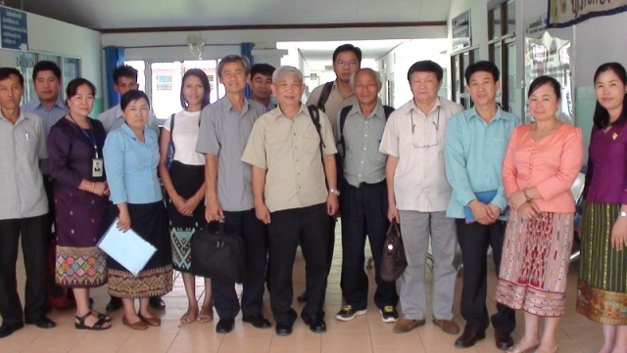

Health Office of Luang Namtha District

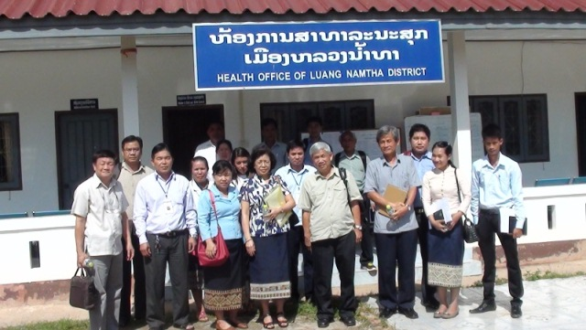

Chaleunsouk Health Center

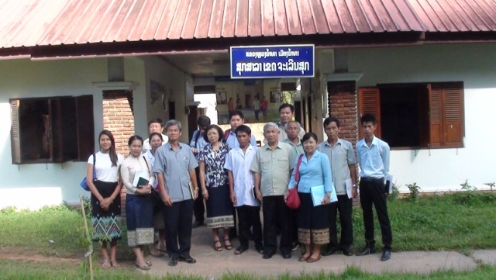

Health Office of Sing District

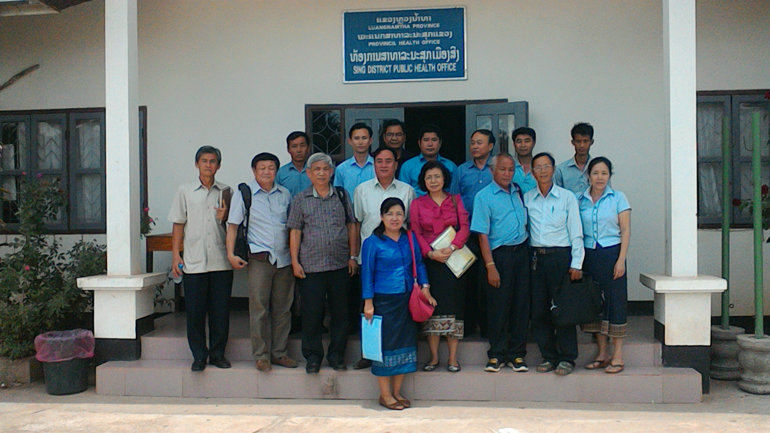

Nam Dai Health Center

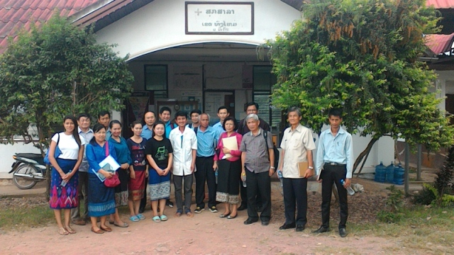

Phoudonthan Health Center

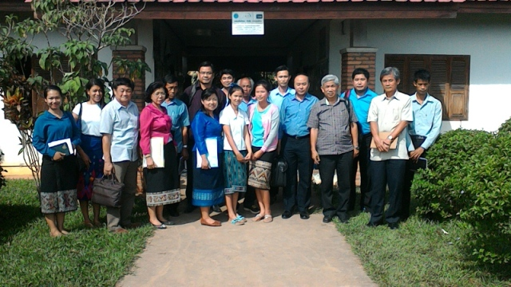

ARV Center (Provincial Hospital)

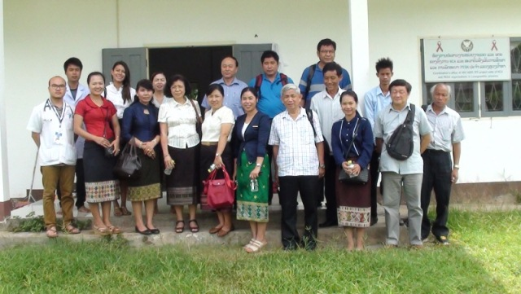

Malaria Station​​

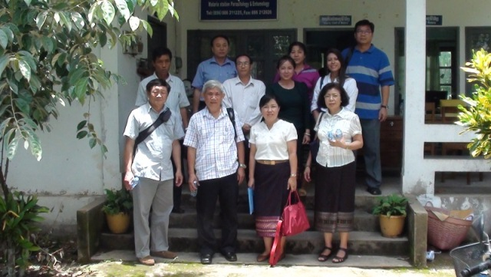

Nateuy Health Center
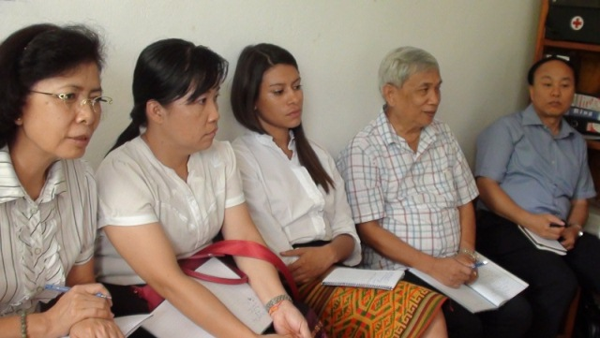

Provincial Health Department

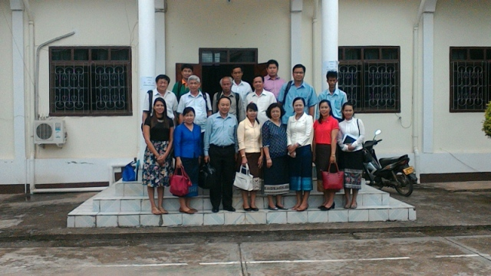

Thanks:
Oversight field visit team of the Country Coordinating Mechanism of Global Fund to Fight HIV/AIDS, Tuberculosis and Malaria would like to express our thanks to the guidance of the Provincial Health Department of Luang Namtha Province, ARV Center, Provincial Hospital, Malaria Station, Health Office of Luang Namtha and Sing District, Chaleunsouk Health Center, Namdai Health Center, Phoudonthan Health Center and Nateuy Health Center as well as all related officials who participated and be hospitality cooperation to carry out this oversight field visit.

Capital Vientiane, Date _____________

Oversight Field Visit Team Leader Reporter
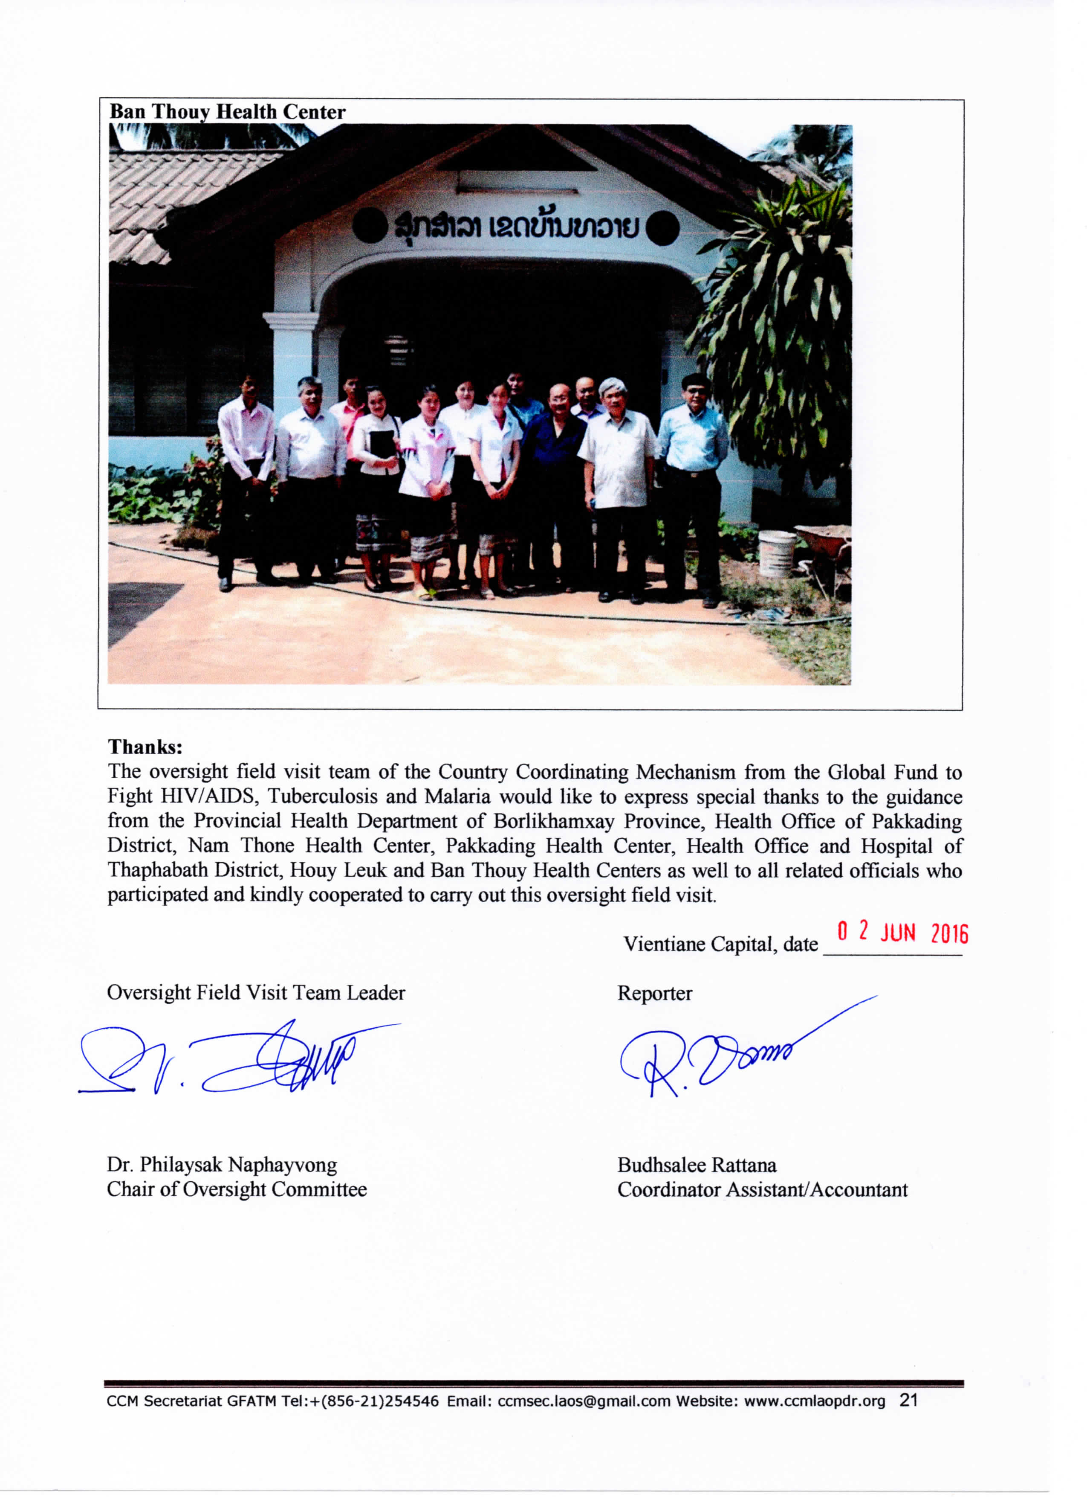

Dr. Philaysak Naphayvong Budhsalee Rattana
Chair of Oversight Committee Coordinator Assistant/Accountant

